RONAN TYNAN

IRISH TENOR & PARALYMPIC CHAMPION

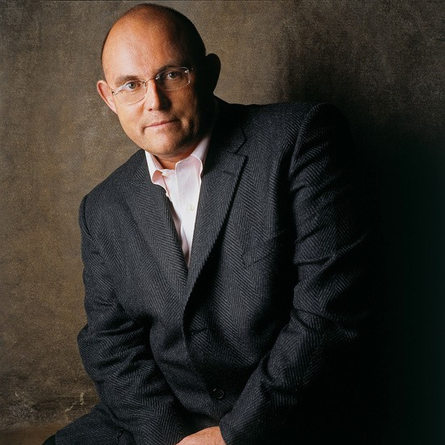
Ronan Tynan is a modern-day Renaissance Man, known for his exceptional talents and unwavering determination. Overcoming significant challenges, he has achieved remarkable success as a world-renowned tenor, physician, Paralympic athlete, and motivational speaker.
Ronan's journey to fame began with the Irish Tenors, where his unique voice captivated audiences worldwide. Following his mother's advice to pursue his dreams, he embarked on a solo career, earning fame and adoration beyond his imagination.
His performances, including "Amazing Grace" at
President Ronald Reagan's funeral and "God Bless America" at Yankee Stadium, have touched millions. Ronan's ability to console and inspire was particularly evident after 9/11, as he supported the New York Police and Fire Departments and their families.
Ronan's debut album in 2005 showcased his versatility and reached high acclaim on various charts. His career has been highlighted by performances at the White House and other prestigious venues, demonstrating his enduring appeal.
Despite facing challenges, including a lower limb disability, Ronan's determination has led to extraordinary achievements. His story of resilience and triumph continues to inspire audiences worldwide, making him a sought-after motivational speaker.
Ronan's profound connection with American audiences reflects his admiration for the country's spirit and support. He remains grateful for the opportunities America has provided him and continues to delight audiences with his music and humor.

Executive Speakers Bureau • richard@executivespeakers.com

