PURSUE YOUR SUCCESS WITH BLIND AMBITION

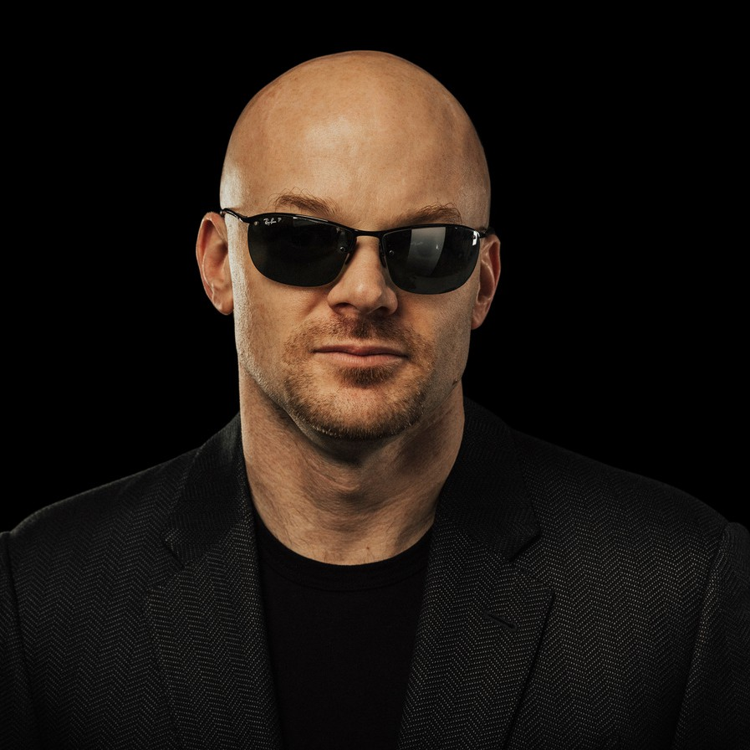
Read Chad E. Foster’s resume and you know he’s a rainmaker. A billion-dollar revenue generator, a job creator, a tech innovator. What’s not so obvious? He’s blind. And when he speaks to audiences, he shares a powerful message: His loss of eyesight as a young adult didn't hold him back. Instead, he embraced obstacles as opportunities.
Chad became the first blind executive to graduate Harvard Business School's leadership program and did what Oracle said couldn’t be done, becoming the first to create CRM software for the visually-impaired. Turning
adversity into advantage, he thrived at a Fortune 500 company, directing financial strategies that resulted in billions in revenue, industry-leading growth, and best-in-class margins despite hypercompetitive market conditions.
Today, Chad teaches this same overcomer mindset to companies around the world, breaking down the anatomy of resilience using his tried and tested tools to empower people to emerge from setbacks stronger, sleeker, and resolute to succeed. He believes in helping others turn their challenges into opportunities, a mission that he values even more than his eyesight.
Connecting inspiration to implementation™, Chad provides a roadmap for overcoming obstacles and achieving the impossible. His keynotes are a blend of heartfelt stories, entertaining delivery, no-fluff truth-telling, and practical strategies tailored to empower individuals and teams to transcend their limitations. With Chad, audiences receive actionable insights on fostering a mindset of growth and resilience, driving them to redefine their boundaries.
His keynotes are not just talks; they are transformative experiences that ignite change, inspire action, and unlock potential. When you invite Chad to your event, you’re securing a catalyst for positive transformation, leaving your audience motivated, equipped, and eager to tackle their challenges with newfound vigor.

BIO CONT’D

His direct and confident style, combined with a go-for-it inspiring belief system — he is an avid downhill skier and Brazilian Jiu-Jitsu practitioner (that’s not a joke), has made him a high-impact keynote speaker for leaders at companies such as Google, IBM, Salesforce, GE and Microsoft. He’d be honored to inspire actions that drive outcomes at your next event.

