WORLD-RENOWNED ASTROPHOTOGRAPHER KNOWN FOR ONE OF ‘HISTORY'S MOST AMAZING PHOTOS'
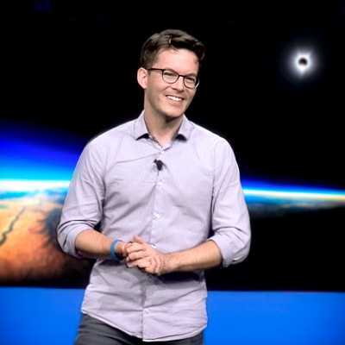
Jon Carmichael is a world-renowned astrophotographer who took what is known as one of “history's most amazing photographs." He captivated the world when he unveiled his image of the 2017 Great American Eclipse from an airplane at 39,000 feet, after years of meticulous planning. The thrilling story behind the photograph and the shocking challenges he overcame have inspired audiences around the world.
Jon is not only an extraordinary astrophotographer but also an incredible storyteller and business motivational speaker. He emphasizes the importance of curiosity in
driving innovation and creative thinking within organizations, sharing his own journey of how curiosity led him to pursue astrophotography and achieve remarkable success. His inspiring storytelling encourages audiences to explore their own passions and approach challenges with a fresh perspective.
Jon has spoken for countless organizations, inspiring creativity and innovation in their teams, and igniting audiences with curiosity, ambition, and a will to persevere. He helps businesses understand the value of fostering a culture of curiosity to unlock creative potential and drive innovation, offering practical insights and strategies for cultivating curiosity within organizations.
Jon and his work have been featured on Good Morning America, Wall Street Journal, INC Magazine, USA Today, and Times Square. He has 17 years of experience documenting corporate and political events, and has partnered with many leading brands including Twitter, Dell, and ESPN. He has had the honor of working with many inspiring luminaries including Presidents Obama & Biden, the Dalai Lama, David Copperfield, Lady Gaga, and many others. His career took a transformative turn in 2015 when Elton John, a prolific collector of photography, discovered and became the first collector of his limited edition photographs.

BIO CONT’D

Jon’s awe-inspiring visuals of the cosmos serve as a powerful metaphor for limitless possibilities, encouraging teams to think beyond conventional boundaries. His engaging presentations and interactive sessions leave audiences with a renewed sense of wonder and a drive to embrace curiosity in their work.

