FORMER DEFENSE INTELLIGENCE AGENCY CYBER DEPUTY DIVISION CHIEF AND SENIOR INTELLIGENCE OFFICER
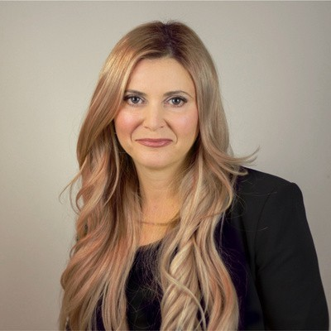
Tyler Cohen Wood is an internationally recognized technologist and thought leader with over 21 years of highly technical experience, including 13 of which were spent working for the Department of Defense (DoD). She sits on several global advisory boards such as the Global Cybersecurity Association, EC-Council Incident Handlers global board amongst others.
She is the Co-Founder of the startup, Dark Cryptonite, which is working on leading-edge U.S. patent-pending technology to revolutionize the way governments and businesses operate, making data virtually 100% safe from
cyber terrorism and information warfare. Dark Cryptonite utilizes advanced blockchain algorithms and zero trust models to be the world's first 'All Digital Bunker'.
Tyler is also the Founder and CEO of MyConnectedHealth Inc., a unique global healthcare platform that connects the best of technology (AI, ML), healthcare, and secure patient crowd data to strategically diagnose and treat disease. Tyler also hosts a live talk show called “MyConnectedLife” on the Voice America network that discusses cybersecurity, health tech, fintech, and all the latest cyber hot-button issues.
Tyler has worked in the private sector as a Director of the Cyber Risk Management group at AT&T, using thought leadership and her cybersecurity expertise to develop new and inventive solutions to protect customers from hackers and the ever-increasing cyber threat landscape.
Prior to that, Tyler worked at the U.S. Defense Intelligence Agency (DIA) under the DoD, serving as a Senior Intelligence Officer, Deputy Cyber Division Chief of the Special Communications Division, and the DIA Science and Technologies Directorate-selected Cyber Subject Matter Expert (SME). While at DIA, she developed highly technical cyber solutions, cybersecurity awareness training, and made recommendations and decisions significantly interpreting, developing, and changing critical cyber initiatives and directives affecting current and future DoD and intelligence

BIO CONT’D
community programs. She has helped the White House, DoD, federal law enforcement, and the intelligence community thwart many threats to the United States cyber security.
Tyler was also responsible for developing and leading many interagency working groups and task forces to develop, assess, and deconflict advanced technical capabilities, techniques, and cybersecurity awareness training currently being used by U.S. Special Forces and the intelligence community to conduct special operations and missions.
As a keynote speaker, author, national security expert, and overall cyber authority, she is relied on to provide unique insight into cyber threats, cyber warfare, mitigating cyber risk, national security, and ensuring industries have the tools and knowledge they need to defend themselves in the digital world. She has received many awards such as Top 10 Cybersecurity Keynote Speakers in Onalytica’s 2021 report, “Who’s Who in Cybersecurity and The Top Influencers and Brands, Cybercrime magazine’s Top 30 Cybersecurity Experts to Follow in 2021”. She was also listed as "Top 50 Women in Tech Influencers to Follow 2021" by The Awards Magazine, 30 Most Inspiring Women in AI 2021 by Engati, Top 10 Cybersecurity Speakers and Influencers by Kevsbest, and is a Finalist for Cybersecurity of Woman Leader of the Year 2021.
She has given many empowering keynotes and presentations for companies ranging from start-ups to Fortune 100s. Tyler has been a keynote and session speaker at conferences such as RSA, Defcon/Blackhat, HTCIA, Bloomberg Legal Conference Series, DoD Cybercrime Conference, ISSA, ISACA, EY Global and Mobility Talent Conference Berlin, A Gateway to Cybersecurity, Annual Corporate Fleet Conference (AFLA 2018), EC Council, Hacker Halted, FedEx Cyber Security Conference, BankersWeb Conference, Canadian Pharmacy Conference, Raymond James, Chicago Mercantile Exchange and many more.
Tyler’s expertise has made her a highly sought-after guest and writer for both national and local television, radio, print, and online media. She has been featured on Good Morning America, FOX and Friends, CBS Evening News, ABC World News Tonight, Bloomberg, CNN, FOX, CBS, ABC, NBC, WGN, among others, and in The Wall Street Journal, Washington Post, and Huffington Post.

BIO CONT’D
She is also the author of Catching the Catfishers: Disarm the Online Pretenders, Predators, and Perpetrators Who Are Out to Ruin Your Life (2014, The Career Press), which teaches how to safely and successfully navigate the online world, and protect yourself, your children, your business and your privacy.

