DR. TED JAMES

MEDICAL DIRECTOR & ASSOCIATE PROFESSOR, HARVARD MEDICAL SCHOOL LEADER IN HEALTHCARE TRANSFORMATION
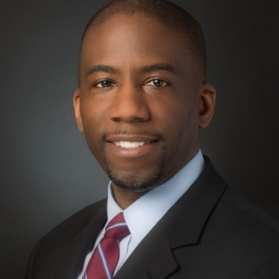
Dr. Ted James is a frequent keynote speaker with a passion for transforming healthcare. Drawing from over 15 years of experience as a physician leader, executive coach, and strategic advisor, Dr. James leverages his knowledge of the healthcare ecosystem and the factors driving change within the landscape. He has spoken to audiences worldwide, sharing principles for building high- performing teams, aligning healthcare technology with current needs and emerging trends, and developing leaders at all levels of an organization. He delivers inspiring presentations rich with practical insights,
empowering audiences to improve organizational culture and advance innovations shaping the future of healthcare and beyond. His unique combination of humor, insight, and experience makes him an engaging presenter whose talks are always well-received.

Executive Speakers Bureau • genevieve@executivespeakers.com

