FORMER "TOP GUN" FIGHTER PILOT & CEO OF STRATEGIC LEADERSHIP CONSULTANTS

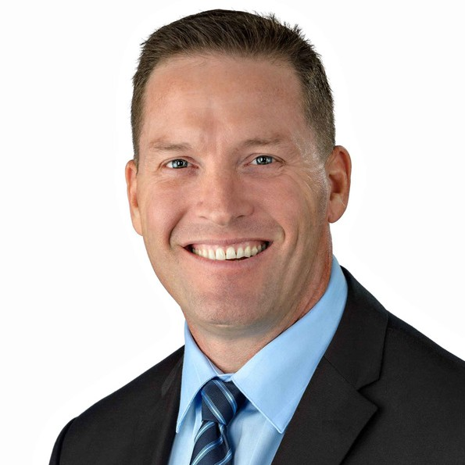
Patrick Houlahan is the Founder and CEO of Strategic Leadership Consultants LLC. Founded in 2019, Strategic Leadership Consultants’ mission is to Build Inspired, Compassionate, Mission-Driven Leaders. Since 2019, Patrick has conducted Keynotes, led Workshops, and Consulted with numerous organizations such as State Farm, Technology Marketing Toolkit, Association of Inside Sale Professionals, and Mission Produce. Patrick has had a distinguished career in both the military and business world.

Patrick graduated from The Citadel in 1992 and was commissioned as a 2nd Lieutenant in the United States Marine Corps. He was stationed in San Diego, CA. serving as a fighter pilot flying the F/A-18 Hornet and deployed twice to the Western Pacific. Patrick graduated from the United States
Navy Post Graduate Fighter Weapons School, “Top Gun,” and served as an instructor pilot. In 2003,
Patrick was selected as the Instructor Pilot of the Year.

After leaving active duty in 2004, Patrick flew the A-10 Warthog with the United States Air Force Reserves and joined the Marine Corps Reserves in 2006. After returning to the Marine Corps, he established the first Reserve Training Unit and continued to serve as an Instructor Pilot. As a reservist, Patrick deployed to Al Assad, Iraq and again to the Western Pacific.

Patrick has trained over 500 replacement aircrew, accumulated over 2800 hours of flight time, and rose to the rank of Colonel. He is a graduate of the United States Marine Corps Amphibious Warfare School, the United States Marine Corps Command and Staff College, and earned his Master of Strategic Studies as a Distinguished Graduate of the United States Army War College. Patrick has served in a variety of roles in the Marine Corps including as a Supply Officer, Maintenance Officer, Operations Officer, and Unit Officer in Charge.

In 2004, after Patrick left active duty and joined Afterburner Inc.. Patrick quickly rose to become an Executive Consultant and Director of Seminars. In 2006 was selected as the San Diego’s MPI (Meeting Professionals International) Speaker of the Year. During his 13-year career at Afterburner, Patrick led over 450 keynotes, workshops, and consulting engagements with today's leading corporations such as Verizon, ExxonMobil, Medtronic, DOW, VMware and H&R Block to name a few.

BIO CONT'D

Patrick has also worked as the account manager for Southern California for Kratos Public Safety and Security, as the Director of Business Development for Citadel Defense Company, and as the Organizational Development Executive (ODE) for Brooks International. As an ODE, Patrick worked with numerous executive leadership teams and was responsible for gaining consensus and alignment in support of the CEO’s imperative.

Throughout his career, Patrick recognized that the organizations that succeeded in any endeavor possessed great leaders. Those that did not, failed. Recognizing the need for leadership training, Patrick founded Strategic Leadership Consultants in 2019 to help organizations Build Inspired, Compassionate, Mission-Driven Leaders.

