INTERNATIONALLY KNOWN STAND-UP COMEDIAN & ACTRESS | HOST AND ENTERTAINER KNOWN FOR HER "HUMOR WITH A HEART"
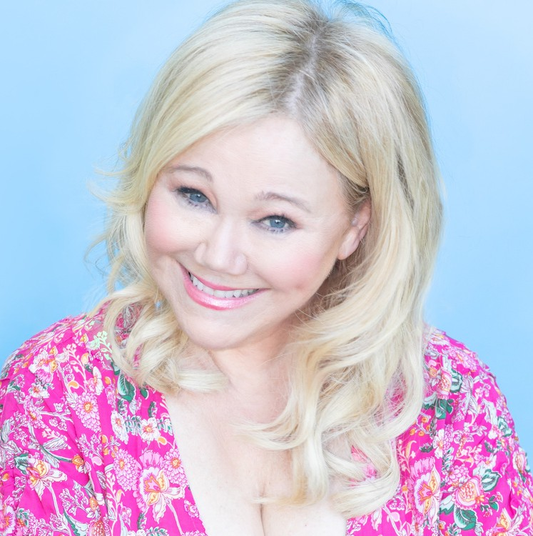
Caroline Rhea is a stand-up comedian, actress, writer, director, and talk show host, best known for her role as “Aunt Hilda” on the ABC hit comedy series, Sabrina the Teenage Witch. She has starred in seven comedy specials for Comedy Central, HBO, Showtime, CBC and most recently filmed her latest special at the Sydney Opera House in Australia. She is on television every day somewhere in the world and tours with sold out comedy shows across the country and internationally. Caroline currently stars as the voice of “Linda Flynn-Fletcher" on the hit Disney animated series, Phineas and Ferb. She
continues to leave an indelible mark on the entertainment world with her exceptional talents and infectious charm. Born in Montreal, Canada, she embarked on her journey in the realm of stand- up comedy, capturing hearts all over the world with her razor-sharp wit and magnetic stage presence.Caroline has graced countless stages, leaving audiences in stitches with her uproarious comedic routines filled with heart.

Caroline Rhea's performances are like a burst of laughter-filled sunshine, leaving audiences craving more. Her comedic genius is not only in her impeccable timing but also in her unparalleled improvisational talent to connect with people on a personal level. Her relatable humor touches the heartstrings of all who witness her magic. From sold-out comedy shows to memorable television moments, Caroline's work has become a source of joy and laughter for countless fans. Her infectious energy and genuine love for making people laugh have earned her a special place in the hearts of many, cementing her as a comedic icon for the ages. Caroline Rhea's career is a testament to her exceptional talent and the enduring love that people have for her work and performances.

BIO CONT’D

Caroline’s television roles also include NBC’s comedy series, Lopez vs. Lopez, Jon Cryer’s new Extended Family, and Sordid Lives: The Series as well as the film, A Very Sordid Wedding. She starred in the Hallmark film, A Mrs. Miracle Christmas, Disney’s Sydney to the Max, Mom’s Got a Date with a Vampire, and HBO’s “Curb Your Enthusiasm,” written by and starring Larry David. She also appears on panels for game shows, Funny You Should Ask, Match Game, and Blank Slate.She hosted her own syndicated talk show, The Caroline Rhea Show. Some of her feature film roles include Christmas with the Kranks with Tim Allen and Man on the Moon, the story of the late comedian Andy Kaufman, with Jim Carrey. Appearances on late night television as well as daytime include The Tonight Show with Jimmy Fallon, and previous hosts Jay Leno and appearing with Conan O’Brien, 35 times. She is a favorite guest with ABC’s Kelly and Mark and appears on many other talk shows and podcasts.

Caroline gives back in many ways including her involvement with Habitat for Humanity, Comedy Fantasy Camp, St. Jude, Broadway Cares, Gateway, Comic Relief and other philanthropic involvements.

