INSPIRATIONAL LEADERSHIP & CHANGE MANAGEMENT SPEAKER BESTSELLING AUTHOR OF YOU ARE ENOUGH
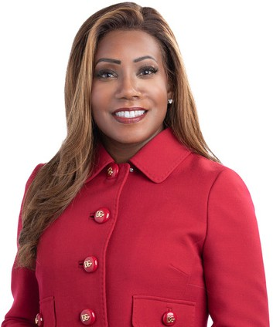
It's choice, not chance, that creates great leaders; It's choice, not chance, that creates a strong workplace culture; and It's choice, not chance, that changes your life.
As the world continues to evolve, its impact on businesses and corporate leadership can’t be overlooked or underestimated. Many leaders have been struggling with myriad challenges with few tangible resources to guide them. Charlene Wheeless is a powerhouse communications leader who provides audiences with a keen understanding of not only the issues they face, but
also the wisdom and experience to tie these together and show how addressing the root causes can strengthen their performance, leadership capabilities and influence. In other words, she will help you choose CHOICE not CHANCE to build an intentional culture.

Before starting her own firm, Charlene was the Principal Vice President of Corporate Affairs for a
$40B global infrastructure company. She was responsible for a host of internal and external communications including reputation risk management, issues management and sustainability. On stage, Charlene makes an immediate impression with sage guidance as a successful business executive and leadership consultant, but with the deeper value of lived experiences as a woman of color and a cancer survivor. No matter her circumstance, Charlene focused on one guiding principle throughout her life which was to choose choice, not chance, in order to reach her goals.

Her key takeaway for employers and their employees is that each person has a choice in the outlook they choose, and it is that choice that could create the most dynamic and most powerful outcomes.

BIO CONT'D

An accomplished author, Charlene also stresses how you must reclaim your life with purpose and passion. Her book, You Are Enough! Reclaiming Your Career and Your Life with Purpose, Passion, and Unapologetic Authenticity has quickly become a blueprint for a healthier approach to reaching your goals.

Charlene continues to emerge as an influential professional on equity and justice and has appeared in scholarly and media outlets including,The Dialogue Project, Forbes, Business Insider and Chief Executive. In 2021 she was hand-selected to be a member of Marshall Goldsmith’s prestigious 100 Coaches, a collection of top executive coaches and leadership thinkers dedicated to paying it forward. Charlene has also been awarded many accolades throughout her career including two Telly awards and more than 50 additional communications and leadership excellence awards. PR Week named her to their Global Power Book for most influential professionals in PR for five consecutive years while The Network Journal named her among the 25 Most Influential Black Women in Business.

Charlene is equally committed to her community, serving as the immediate past chairman of the HCA Virginia-Reston Hospital. Other board positions include the Institute for Public Relations, the Page Center, the Diversity Action Alliance, and The Black Experience, an effort to amplify the voices of leaders in the Black Community.

Charlene is a certified leadership coach and is a member of the National Speakers Association, in addition to other professional associations. She holds a BA in Journalism/PR, an MA in Public Communications, and an MBA with an emphasis in Marketing.

