FORMER PRESIDENT OF KEURIG, INC

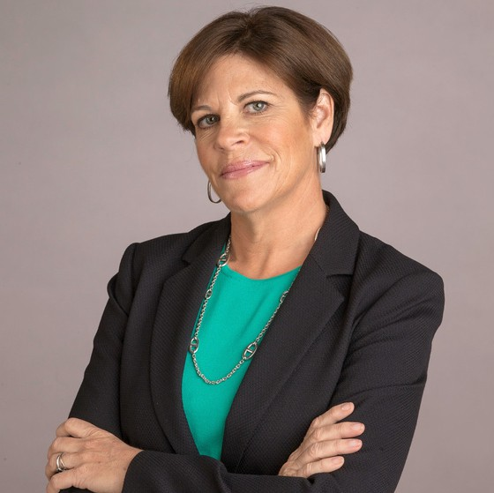
If you drank a cup of coffee, brushed your teeth, or shaved this morning, your life has already been impacted by Michelle Stacy’s leadership.
Michelle Stacy is a senior leader with the consistent ability to run and scale businesses, and a commitment to creating world-class cultures by developing and articulating a clear vision that ignites the organization to deliver innovation, drives P&L focused top-line growth, and builds powerful global brand franchises. She creates a forward-thinking vision and executable plans that have driven strong growth at Gillette, P&G, and Keurig by
leveraging the combination of new product innovation, acquisition, eCommerce/social media, brand building, and overall excellence in marketing and sales execution. Of tremendous value has been her operational expertise across all functional areas including manufacturing, R&D, procurement, distribution, and IT, and her ability to create a positive and focused culture that delivers both financial results and a commitment to a higher purpose.
Michelle is currently on the Board of Directors of iRobot Corp, Bellwether Coffee, and Zesty Paws. She previously held Board seats with Hydrafacial, Tervis Tumbler Company, Eargo, and Young Innovations Inc. Michelle is also a Director Advisor to The Cambridge Group (an AC Nielson Company) and the Expert in Resident at the Harvard Innovation Lab. As a sought-after professional speaker, Michelle speaks on leadership, culture, innovation, and overall business strategy & execution.
In her previous position, Michelle was President of KEURIG, INC., a $2+ billion division of Keurig Green Mountain [NASDAQ: GMCR], where she had full P&L leadership with direct reports in all functional areas and directed marketing and operations of all products across all sales channels, including management of the business partnership network. During her five-year tenure, Keurig's single-serve coffee system grew from 2+ to 16+ Million installed households delivering a CAGR of

BIO CONT’D

61% in net sales and 74% in operating income and propelling total GMCR sales from $493 million in revenue in 2008 to $4.3 Billion revenue for FY 2013. Her commitment to leadership, sustainability, and culture resulted in Keurig being elected to the top 10 places to work in Massachusetts two times.
Prior to joining Keurig, Michelle had a successful 25-year career with GILLETTE including the PROCTER & GAMBLE acquisition of Gillette in 2005. In her last role at P&G, she was Vice President & General Manager Global Profession - Oral Care where she directed the Global Professional activities for the Crest and Oral-B brands, led 700 people in 70+ countries, oversaw
$220MM in net sales, delivered over $20MM in cost reduction and integration efficiency, and created a highly efficient global organization structure. Her previous positions at Gillette included Vice President, Global Business Management-Oral-B, Profession and Kids Oral Care, leading the global management and development of the kids business and the B2B Professional business; and Vice President, Global Business Management – Manual Oral Care, overseeing global business planning focused on product development and international market expansion including the launch of Oral-B Pulsar.
Previous leadership roles at Gillette included Vice President, Global Business Management- Stationery Products Division at Parker & Waterman, providing global general management and new product innovation, and participating in the divestiture team negotiating the Rubbermaid acquisition in 2000; Vice President of Marketing, Grooming and Personal Care with net sales >$1.4 Billion, including the Launch of Gillette Mach3 in the USA.
Michelle started her career in product management at CLAIROL and RICHARDSON-VICKS. She received her Masters in Management from J. L. Kellogg Graduate School of Management at Northwestern University, her B.S. from Dartmouth College.

