CRIMINAL JUSTICE ADVOCATE & AUTHOR OF POSTER CHILD

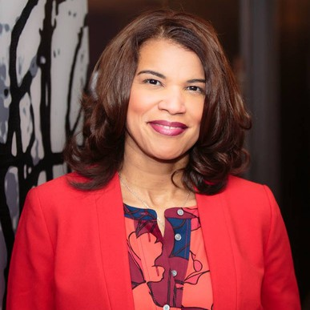
Kemba Smith Pradia went from college student to drug dealer’s girlfriend to domestic violence victim and in 1994 she was sentenced to 24.5 years in federal prison. Kemba’s case drew support from across the nation.
Often labeled the “poster child” for reversing a disturbing trend in the rise of lengthy sentences for first-time, non- violent drug offenders, Kemba’s story was featured on a variety of television shows and in several publications. The support prompted then-President Clinton to commute her sentence in December 2000, after having served 6. 5 years in prison.
Today, Kemba is a wife, mother, public speaker, advocate, consultant, and author of Poster Child. She has worked with senior officials at The White House, the United Nations in Geneva, Switzerland, and Members of Congress, and has led trainings for Federal and State Probation organizations across the country. Corporations such as Verizon, Traveler’s Foundation, Proctor and Gamble, Bank of America, and Gulfstream have sponsored her to speak at events across the country. She has received numerous awards and recognitions for her courage and determination as a motivational speaker and advocate.
In 2019, Kemba was appointed to the Virginia Parole Board by Governor Ralph Northam and served for over two years. In January 2022, she involuntarily separated from the State due to the transition of a new gubernatorial administration. Prior to her appointment, she served on the Virginia Criminal Sentencing Commission and held the position of State Advocacy Campaigns Director with the ACLU of Virginia.
Currently, Kemba is an entrepreneur, consultant, and executive producer of KEMBA, an MPI original Film that is inspired by her life story. She continues to serve on the Board of Directors for Virginia CARES and Drug Policy Alliance. She is also a member of Delta Sigma Theta Sorority, Inc., the NAACP, the National Association of Black in Criminal Justice, and Co-convener of the Justice Roundtable.

BIO CONT’D

Along with being an advocate for criminal justice reform, Kemba is the founder of her 501 (c) 3, The Kemba Smith Foundation. Ultimately, Kemba knows that there is a lesson in each experience in life, and she has embraced her experience, learned from it, and is now using that experience to teach others.

